Project

Multimodal study of functional organization of the Visual Word Form Area

Chotiga Pattamadilok ^{(1),} Shuai Wang ⁽¹⁾ & Ken Pugh ⁽²⁾
- LPL, (2) Haskins Lab

Abstract
Reading acquisition establishes the functional and anatomical connections between the auditory and visual systems. Interestingly, this recurrent communication between the two systems also induces profound changes in the activity and the property of neurons within each sensory system itself (Dehaene et al., 2020). Our recent study using a combination of Transcranial Magnetic Stimulation and an adaptative protocol (Pattamadilok, Planton & Bonnard, 2019) showed that the Visual Word Form Area (VWFA), i.e. , the key area of the reading network, not only contains neurons that encode orthographic information as currently assumed, but also those that encode phonological information. The emergence of these spoken language coding neurons in the ventral visual pathway could be considered as cortical reorganization subsequent to learning to read.
The present protocol aims to further investigate the fine-scale spatial organization of functionally segregated neuronal populations within the VWFA. The issue will be addressed in a fMRI study using a repetition suppression paradigm. Both univariate analysis and Representational Similarity Analysis will be applied to examine fine-grained patterns of activity within the VWFA.

Publications

Fiche-résumé contribution CREx

AVA (en cours)

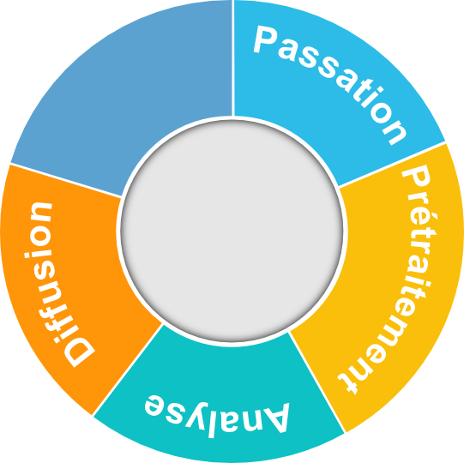
Multimodal study of functional organization of the Visual Word Form Area
IRMf
IRMf
IRMf
Investigateurs : Chotiga Pattamadilok (LPL), Shuai Wang (LPL) & Ken Pugh (Haskins Lab)
Durée : depuis janvier 2020
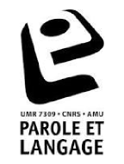
Contribution : Aide à la passation, au prétraitement, à l’analyse et à la diffusion des données.
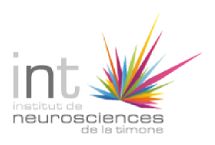

▮ Passation – Aide à la passation réalisée auprès de 22 volontaires adultes
▮ Prétraitement –
▮ Analyse –
▮ Diffusion –

