Creative economy as a social innovation: lessons from Rio de Janeiro Pontos de Cultura.
Dalia MAIMON SCHIRAY
Cristine CARVALHO
Ana Paula de Sá CAMPELLO

Abstract
This article aims to highlight the aspects of innovation and creative entrepreneurship in cultural projects of fifty non-governmental organizations – NGO located in Rio de Janeiro city, named as Pontos de Cultura (Points of Culture) by the local municipality. The conceptual and analytical framework are based on literature review on the themes of creative economy and social innovation.
In the last three decades, social innovations have been debated in different sectors of society, including a variety of activities associated with non-profit organizations, social entrepreneurship, social economy and corporate social responsibility practices (Schachteret al, 2012). Furthermore, as Mulgan, Sanders and Tucker (2007) maintain, there are many lenses through which understand social innovation, as well a variety of approaches related to multiple subject areas.
The work is divided into four parts. The first one analyzes the main approaches of social technology and the creative economy, pointing distinctions between international approach that combines creative economy with the latest technology and the Brazilian reality where the focus is on social entrepreneurship.
In the second part are emphasized methodological issues related to the collection and analysis of data. Later, in the third section, we submit the analysis of the cultural projects based on the thesis of innovation stages of organizations, (Caulier - Grice and Mulgan, 2010): (1) factors that trigger action (prompts), inspirations and diagnostics; (2) proposals and ideas; (3) prototypes and pilots; (4) support; (5) design and dissemination; (6) systemic change.
Finally, in the last section are outlined the final considerations about the study, limitations and suggestions for future research.
Keywords: Creative Economy, Social Innovation, Rio de Janeiro, low-income community.

1. Introduction
In the last three decades, social innovations have been debated in different sectors of society, including a variety of activities associated with non-profit organizations, social entrepreneurship, social economy and corporate social responsibility practices (Schachteret al, 2012). Furthermore, as Mulgan, Sanders and Tucker (2007) maintain, there are many lenses through which understand social innovation, as well a variety of approaches related to multiple subject areas.
The paper is divided into four parts. The first one analyzes the main approaches in the fields of social innovation and creative economy,pointing distinctions between international approach that combines Creative Economy with innovation and the Brazilian reality where the focus is on social entrepreneurship in creating income, as analyzed by Maimon et al (2015).
The second part explains the results of the research of the creative entrepreneurship recognizedby the municipality of Rio de Janeiro as Pontos de Cultura (Cultural Points). We emphasized methodological issues related in the survey and data, and later, weclassify NGO’s cultural projects according to Murray innovation stages, Caulier-Grice and Mulgan(2010). These stages are: (1) factors that trigger action (prompts), inspirations and diagnostics; (2) proposals and ideas; (3) prototypes and pilots; (4) support; (5) design and dissemination; (6) systemic change.
Finally, in the last section are outlined thelessons, limitations and suggestions for future research.

2. Theoretical considerations

2.1 Social innovation
Innovation is generally understood as a new widespread activity within a given context, and linked to economic gain and profit generation. Studies on the subject run of Schumpeterian conceptions that new combinations allow to obtain extraordinary profits (Bignetti, 2011).
Murray, Caulier-Grice and Mulgan (2010) emphasize that social innovation is distinctive to innovation in business as usual because of its outcomes and relationships - new forms of cooperation and collaboration. The processes, metrics, models and methods used in innovation in the commercial or technological fields, for example, are not always directly transferable to the social economy.
Reflection on social innovation has attracted the interest of researchers and professionals from various fields, however, one realizes there is no consensus on its definition and scope. Schachter et al (2012) agree that the research is diverse and fragmented, including interdisciplinary approaches, such as economics, sociology, social entrepreneurship, creativity, political science, urban development and human development.
Bouchard (2012) identifies two major approaches to social innovation. The first is interested in solutions to major social problems, based on business initiatives, with an emphasis on philanthropy, individual responsibility and market. The other approach emphasizes the collective nature of the processes and products of social innovation (Bouchard, 2012). Levesque (2007) argues that innovations are seen as measures or policies that lead to social change and transform the relations that are at the root of social problems. In this case, innovation cannot be considered as resulting exclusively from a voluntary and rational action. These innovations rely on the participation of various social actors, in order to promote changes associated with living conditions and local development.
In this research, we focus on the collective nature of social innovations, relating to demands and social changes, which involve cooperation between differentactors. Added to this discussion, Bittencourt (2014:329) mentions that "the definition of social innovation reveals practices of cooperation, reciprocity and solidarity, in which the social actor moves at social networking with purpose watch a situation of discomfort or an ideal in common."
Bouchard (2012) points out that social innovation is associated with the intervention of social actors, to meet specific needs in favor of social change. Similarly, Lévesque (2007) points out that social innovation, and propose responses to specific needs, aimed at social change, in that it requires a new vision, a new way to see and define problems and solutions to these problems (Levesque, 2007). These perspectives have been adopted by researchers at the Centre de Recherche sur les Innovations Sociales (CRISIS), which conceptualize social innovation as an intervention initiated by social actors to respond to a human aspiration, meet a need, a solution or seize an opportunity action to change social relations, to transform a frame or propose new cultural orientations to improve the quality and community living conditions (CRISIS, 2012; Klein et al 2009.).
To support public policies, Murray, Caulier-Grice and Mulgan (2010) propose some stages in the development of social innovations, providing a framework for thinking about the different types of support that innovators and innovations need to grow. These stages are: (1) factors that trigger action (prompts), inspirations and diagnostics; (2) proposals and ideas; (3) prototypes and pilots; (4) support; (5) design and dissemination; (6) systemic change.
The Process of Social Innovation
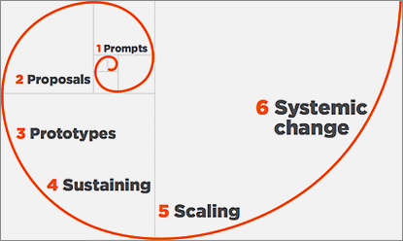
Source: Murray, Caulier-Grice and Mulgan (2010)
According to Murray, Caulier-Grice and Mulgan (2010) the first stage refers to the perception of a problem, a lack or an inability of the public or private sector to respond through traditional means action. At this stage its attack the roots of the problem, not just the most visible symptoms. The second stage is associated with the creation of ideas, drawing on the creativity to break new ground in troubleshooting. The third stage involves the development of prototypes and pilots, with the intention of testing the ideas in practice. Refers to learning by doing where they can be redefined new ways. The fourth stage involves the economic support long-term, including the creation of budgets and resource allocation. The fifth stage (design and dissemination) is associated with the expansion of the action or broadcast to a larger area of coverage and, finally, the sixth stage, refers to systemic change, considered the ultimate goal of social innovation, which implies a permanent and sustainable change.
These steps are not always taken in sequence, with possible feedbacks and interactionsbetween them. Authors suggest that the development of social innovation can be driven from these stages, which should impact on sustainable change.
It can be seen therefore that the multiplicity and range of theoretical approaches to social innovations give a complexity that goes beyond its conceptual definitions also permeating the interactions between the actors involved in the promotion of lasting social change.

2.2 Creative economy (CE)
A new dynamic sector related to artistic productions, services and cultural industry has emerged in world trade. These sectors use creativity and intellectual resources, such as knowledge and culture, as primary inputs in activities, showing no limits in use of science and technology to promote innovation and generation of values. These creative assets are being used in different sectors of the economy, enabling them to face the new challenges of everyday life.
In the UK, the pioneer in promoting the so-called “creative industry”, the government defined the sectors of that industry as those whom uses creative skills and individual talents as inputs of the production. It can be seen in advertising firms, design, architecture, art, antiques market, crafts, performing arts, fashion, audiovisual, software, games and bibliographic publications.
According to Reis (2008),theEnglish initiative is a reference in promoting the creative economy for three reasons, (1) contextualize the creative industries program in response to a global socio-economic framework in change; (2) privilege the sectors of more competitive advantages for the country reordering public investments priorities; and (3) dissemination of statistics revealing a significant contribution of the creative industries in its Gross Domestic Product (GDP).
The Creative Economy Report (UNCTAD,2010) recognized the creative economy as different but not distant from cultural protuction. According to the Report, creative economyis a process leading towards innovation in technology and business practices. The cultural expression (or artistic practice), both individual and collective, first generates income and employment; second energizes and empowers individuals and groups, particularly among the marginalized and down trodden, and which provides platforms for their social and political agency; third is tangible and intangible cultural heritage, which, provides people with the cultural memories, knowledge and skills vital for the forging of sustainable relationships with natural resources and ecosystems.
In terms of spacial location of the creative business, some research efforts have been made on mapping the potential of certain regions as creative poles or “creative cities”. According to Reis (2008), the main characteristics that indicate a good place to develop the creative economy are: (1) local and global connection; (2) mobility, access to public spaces, social and digital inclusion; (3) research and innovation projects in science, culture and society; (4) professionals in different sectors; (5) patent applications, new products and technological projects; (6) tolerance and openness to cultural diversity, religion, use of new technologies, new ideas and people; (7) convergence of action, joints and connections intra and extra poles; chains and networks of production, circulation, enjoyment and exchange of experience; (8) concentration of initiatives - productive vocation contribute to a sector identity on the spot; and (9) business consolidation and the potential for local development.
Although these environmental characteristics showed as favorable to the development of creative business, there are other aspects that are worth mentioning, according to Reis (2008), related to the "need to forge sustainable models of economic inclusion and solve problems urban, environmental and social violence that afflict us”.
From the financial point of view, there is no direct relationship between creativity and socio-economic development, except for the analysis of creative activity cycle through the interaction of four types of resource - social, cultural, human and structural or institutional. The cumulative effects of these determinants are the results of creativity.
The literature on CE produced mainly in the United Kingdom and the United States emphasizes that the creative potential is the availability of high human capital (education level) and access to basic urban infrastructure (REIS, 2008). But as creativity and culture are too close in terms of entrepreneurship, contributions to the study of cultural activities point to the importance of understanding these activities in a systemic perspective.
Briefly, with respect to the spatial dimension, the findings of the different currents indicate common features mentioned cultural activities (Pratt, 2000; O'Connor, 1999). Close coordination between the global level and the local level, and between large and small businesses and independent professionals in complex production networks. Also, a predominance of micro and small enterprises, as well as the presence of a large number of autonomous, organized mainly in urban centers, in industrial agglomerations, which operate separately or in coordination to large enterprises and multimedia distribution networks. There are significant economies of agglomeration, resulting from the use of a common physical infrastructure and communications, disseminating tacit knowledge through interaction networks, formal and informal. All that processes foster creativity, innovation and cooperation in the implementation of productive and creative steps.

2.2.1 Creative Economy in Brazilian context
In 2010, the Brazilian government published the Plan of the Secretariat of the Creative Economy (Ministry of Culture, 2010) in order to lead discussions and formulate public policies to encourage the creative sector as a strategy for economic and social development of the country.
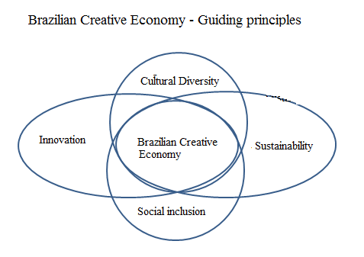
Source: Ministry of Culture, 2010.

After the definition of the activities comprehended as part of creative sector, it could be possible to produce some data about it. 2010, all activities from the creative sectors respond to 2.84% of the Brazilian GDP, 2% of the labor workforce and 2.5% of formal wages (IBGE, 2010). Moreover, workers in the creative economy earn more and are have higher educational levels than average. The multiplier effect of jobs generated in the core of the creative industries in other economic segments calls attention to its power to generate income. It would be even more if it accounts the voluntary or unpaid work, occupations that have not been coded, informality and the fact that many creative workers carry more than one job (IPEA, 2013).
In parallel of the discution about creative economy, the Ministry of Cultureapproved, in 2014, the NationalPolicyof ‘Cultura Viva’ (Aliveculture) aimingtoensurethe Brazilian populationthemeansandconditionsofexercisetheculturerights, including theprotectionandpromotionofthediversityof cultural expressions.
The policy begun with the certificationofthe roganizations who develop culture projects, naming these as Points of Culture (federal, stateand/or city). Additionally, other organizations were selected in order to help increase the Cultural Points, called ‘Pontões de Cultura’ (Big Points of Culture).
ThePoint of Culture articulatethethreedimensionsofculture - symbolic, citizenshipandeconomic, connectingmultiplerepresentationsof feeling, doing, knowingandthinkingwiththe social andproductivecommunities.In a citizen perspective this cultural actioncontributestoenlargethepublicspaceofcultureandpromotethedirectexercisetoculture in differentcontextsandatdifferentpopulations. Besidesexpandingthe cultural equipment,the Points of Cultureare constituted assolidarity economyenterprises, integrated networks, systems andproductive arrangements in the cultural sector.

3.Case study: Pontos de Cultura in Rio de Janeiro Municipality

3.1. Methodology
LARES-IE/UFRJ were selected as Pontão de CulturaEconomia Viva (Big Point fo Culture: “Live Economy”) at 2015 and had interviewdthe representants of 50 Points of Culture from Rio de Janeiro city as part of the participative diagnostic of the project. The differential of participative diagnostic is allowing the organizations team make its own evaluation and planning of intervene.
The diagnostic plans were identify the terms of references and data about the ‘Cultura Viva´ Policy, to search data about the social organizations and to aplly a questionnaire
The field work spent 4-month, between April and July 2015. The interviews were semi-structured based on questions about the project profile, production methods, partnerships, awareness of challenges and growth opportunities. The research group also conducted participant observation in events, taking pictures and making notes about place conditions and social relations presented.
The management of creative projects and the dynamics of relationship between the leadership in local networks pointed to the identification of contextual social innovations associated with the characteristics of the territory. Using as reference Murray, Caulier-Grice and Mulgan (2010) were considered aspects of innovation projects: (1) cultural development: understanding as strategies based on the social, collective, human and environmental; (2) network thinking: combine the government's efforts, the private sector and non-governmental organizations; (3) open system with the collaboration of different actors that add their different expertise and views for troubleshooting; and (4) qualitative indicators: new ways to assess the qualitative growth, which are connected to services, culture, knowledge and entertainment. And from there, we identify their innovation stages as mentioned before.

3.2Surveymainresults
3.2.1 Location
Thedistributionof Points ofCulture in thecityof Rio de Janeiro shows that 33% are located in the City Center neighborhood, 29% in the West Zone, 26% in theNorth zoneandonly 12% in theSouth zone, as indicated in the graphics below.
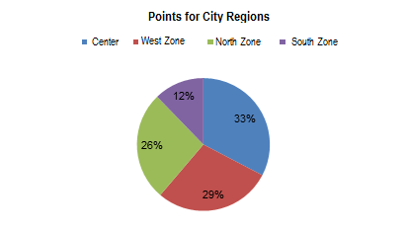
Source: Authors, 2015.
The central region is still the one that has more selected Points of Culture, as well as more cultural equipmentand demographique concentration as indicated in the map.
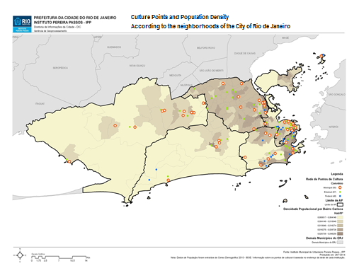

3.2.2 Foundation
Considering the dates of foundation, 39% Points of Cultureare activefrom 11 to 20 years and others 39%from10 years.15% of Points from 21 and 30 years and 7% from 31 to 40 years.
Years of foundation
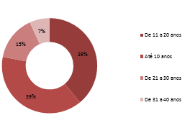
Source: Authors, 2015.

In the distribution along the years is observed relevant numbers of selected Points founded from year 2000, according to the graphic below:

Points of Culture by Year of Foundation

Source: Authors, 2015.
In general, according to IBGE (2010), 51% of Brazilian NGOswas founded between 1991 and 2005, while others 15% in the decade of 80.
3.2.3. Sector of activity
In terms of the activity related to cultural diversity, the interface between the cultural sectors 50Points of Culture appoints how rich and creative are the cultural projects in the city. Looking for the main activity (or project with major impact, or public), the results show that 29% of Points of Culture uses Audiovisual language (including photography and movie), 23% Music and 20% Theater. Below, thepercentual ofPoints of Culture per sector fo activity, where is possible to verify the participation of others 10 areas.
Points of Culture by sector of activity
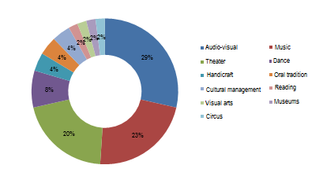
Source: Authors, 2015.
3.2.3.Motivationtosettle in theterritory
The project installation in particular neighborhoodorregionimpliesimpactsonthe local socio-economic dynamics and in theinfluenceofassociative networks, amongotheraspects.The motivation for the development of a cultural project in a given territory can be associated with the installation of the proponent organization on site or in a "customized" way, can act against the target audience or for the subject of work, to the movement which is part of the leadership, for example. Starting from information provided by the interviewees on these aspects were defined motivation categories for the Project installation: (1) prior belonging local to that leadership, (2) availability of space, (3) specific demands location, (3) target audience and (4) other similar initiatives in place.
Among the 50 Points of Culture, 55% indicatethemotivationtoinstalltheproject site isrelatedtothe site alreadybe prior actionleadership. In 31% of points, themotivationisseeking in attendthespecificdemandthatplacethroughtheactionsdeveloped, and 14% takeadvantagedoftheavailabilityofspace in thatareatopromotetheiractivities.
It wasnotedthatthelocalized points workwith a targetaudienceofdifferentlocations in thecityduetoavailabilityofspace, thelocation, in this case, too, isassociatedwiththeminimizationofcostofrent. The otherreasonscited – leadership and local demand are closertothe reality oftheterritory, are associatedwith links ofbelongingandseektoprovideanswerstospecificcontextsofplace.
3.2.4Management
Since PNCV chosetoworkbyprivate non-profitorganization (NGOs). The management andtheavailabilityofphysical, technological, human and financial resources are assumptions of theefficacyof cultural projectsandactivities.
3.2.5 Physical equipment
The availability of physical equipments includes the space used for the development of project activities Culture Point and the available equipment.
In relation to the space used for the activities, it investigated the origin of space and the conditions of the workplace. As seen, (51%)Points of Culture work in assigned areas and 25% in rented spaces. Only 12% carry out their activities in their own spaces. Important to note that among Points of Culture that has ownership of the property are large organizations such as universities.
69% ofrespondentsbelievetheworkspaceissuitable, while for 31% it isinappropriate. The reasontoevaluate it as inappropriateismainlyassociatedwiththe use ofspace for severalotheractivitiesoftheorganization. Locationalaspectswerealsomentioned, such as publicaccessdifficultiesduetothelogisticsofurbanmobilityandthelowlevelof public equipment. Relatedtocontractualaspectsoftheproperty, thereason for inappropriatewasalsoassociatedwithlackofautonomy in promotingchanges in its structure and financial insecurity, bothiscauseoftheproperty'sconditionberentedor assigned.
The relation between the origin of space and the level of satisfaction indicates that in own property the level of satisfaction is 100%, in assigned property the relation is 68% and in rented property, 33%. The chart below illustrates the satisfaction within the property of the source situations.

3.2.6.Technological resources
The main technological resources used by the Points of Culture, in terms of hardware are computers, cell phones and cameras. In terms of software and services are used computer programs, Internet access and mobile telephony, as the data below.
All members of the 50 Points of Culture have cellular mobile device (smartphone) and use it for communication via mobile phones and text messages.
Internet access reaches 49 Points of Culture and only one point has restrictions due to territorial specificities. Of these, 71% of the Points of Culture use internet every day and 29% 3-5 days a week.
The computer and internet access, both in the organization's headquarters and in their homes, are used by the teams of Points of Culture for various activities. Thus, several fields were marked this question, leading to note that the communication actions, such as exchange of e-mails and messages, access to social networks and discussion groups is computer use reason most points, adding 33 organizations (67%). Another important activity is the project management, according to 31 Points of Culture (63%), where it makes use of software, websites and online applications.
Research activities are also carried out by 18% points, which includes the search for information that influence the conduct of the project, from texts, images and audiovisual. Other 18% use the computer as a working tool, understood as a means of realization of the project's main activity, such as editing, production of texts and audio.
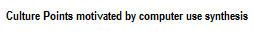
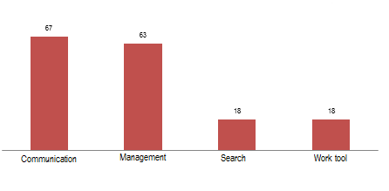
It is interesting to note the importance of technological infrastructure, particularly computers, software and routers Internet access in the management and communication of projects. As reported by respondents, the equipment is used from the information notices and promotion of laws to the preparation of the project and its accountability, as in team communication to disseminate the activities and invitation to the public.
3.2.7.Human resources
Regarding human resources available to the project Culture Point were observed aspects of the formation of the team, the allocation of functions and labor.
In forming the active team on the project, the presence of the same legal representative in the organization from the foundation of the same to the start of the project Culture Point indicates that were not made major changes in the organizational structure as well as the mission and values ​​of the organization. As seen, 94% of the Points of Culture maintains the same legal representative since its foundation.
As the presence of the founder, the presence of the coordinator of the project during its implementation also influences the performance of the team and the same management. According to respondents, 89% of the Points of Culture maintain the same project coordinator.
Still regarding the coordination of the project, the survey of staff payment forms showed that 47% of the points have their projects coordinated by volunteer managers.
Regarding the number of people in the team, considering permanent employees and self-employed service providers, it has been seen that most of the points have between 3 and 7 people on the team, as shown by the graph below, placing large number of Points of Culture in the 3rd quadrant below.

The listing of the functions of each of the team members showed the presence of several activities assigned to one person on the project. Specifically, the coordinator performs several functions, among which accountability, 49% of the Points of Culture.
In 23% of points accounting is the responsibility of the finance department of the organization (in the case of large organizations), and 14% of points is made external counter hiring to do the job. The coordinator of a larger organization is still responsible for the accountability of all the organization's projects in 6% of Points of Culture, and 4% is the executive producer who performs the activity. There is only one case (4%) where the counter is volunteer project.
Points of Culture by responsible for accountability

3.2.8 Points of Culture Team
The teams of Points of Culture are formed by personnel hired exclusively dedicated to the point of activities as well as for services performed in the project. The total number of team members of all Points of Culture reaches 243. In order to verify the means of payment of the members defined the Volunteer categories, Portfolio Signed / CLT - Consolidation of Labor Laws, MEI - Individual Micro-entrepreneurs, RPA - receipt of Autonomous Payment, Scholarship Research and Informal. It was found that 35% of the members of all the Points of Culture are paid by invoice for MEI and 25% by RPA. A striking since, as previously seen for payment of engineers, is that 30% of the Points of Culture members are volunteers. The graphic below illustrates the distribution of Points of Culture members second means of payment.
Team in the Points of Culture

Regarding the teams in the Points of Culture, 56% of the Points of Culture pointed hiring of MEI services (Micro entrepreneur Single) and another 30% of the points uses the payment services Receipt Autonomous Payment - RPA main contracting. Only 8% of Points signs the professional portfolio of employees - CLT and 6% of Points offers Scholarships as the primary means of financing human resources through partnerships with educational institutions like FIOCRUZ and IPUB-UFRJ.
Reducing costs employing taxes is the main reason for the preference for service payment via invoices, in particular MEI, another reason refers to the high turnover of jobs or their short-lived, as the provision of workshops and preparation of a product.
Aspect to note is the large number of volunteers, including occupying positions of responsibility and exclusive dedication. It also observes the practice of "taking out of pocket money" to pay the costs. The following item will present the results of research done on the sources of funding of projects Points of Culture. Resources from the volunteer work and partnerships were not considered in the quantitative survey.
3.2.9.Financial resources
The research about the source of funding of Culture Point projects understands that the main feature is that which comes to the Notice of the Municipal Culture Secretariat, but that the project can be linked to other projects of the organization used its infrastructure, or perform generating activities income. The organization linked to other projects it is public sponsorship (other calls) and / or private (Foundations, ICMS, ISS, Rouanet, etc.) and donations.
According to a survey, 20% of the Points of Culture receives only the use of SMC Notice - Network Culture Point Carioca and 22% of points generate income from products and services of its activities. Regarding the association point the other organization's projects with sponsorship, 37% of the points are associated with other public resources, including, for example, Points of Culture notices from the State and Federal Network; 18% are associated with projects with private sponsorship, 10% receive mixed capital company (public-private) and 14% receives funding from NGOs, associations or foundations. 24% of raises Points of Culture funds from individual donations, including crowdfunding campaigns, for example.
The table below illustrates the participation of several sources of funding the activities of the Points of Culture. It is observed that most of the points uses public resources and collects through donations.
Table 1: Points of Culture by Resource Source
Points of Culture by Type Resource Source | SMC | Products and services | Public | Private | Mixed | Non profit organization | Donations
Number of Points of Culture | 10 | 11 | 18 | 9 | 5 | 7 | 12
% Points of Culture | 20 | 22 | 37 | 18 | 10 | 14 | 24

3.3. Methods for assessing
The control of projects Points of Culture presents quantitative and qualitative evaluation methods associated with the results of activities undertaken in calls to specific objectives. Thus, the work can be measured through invoices or quantitative metrics or comments from beneficiaries and staff meetings.
And the first, all points must submit Accountability with receipt and payment of notes, and validate the presence of the target audience through the Attendance List. These practices are recognized as the sole method of evaluation in 22% of the Points of Culture while the others perform a combination of assessment methods.
An example of the use of combined assessment methods is reported by the coordinator of Lapa Maré Point "quantitative and qualitative reports, evaluate the impact with concrete actions and systematize in a publication. dialogical aesthetic evaluation - is made from interpretation games. "Among the methods used are those made by the team or the audience about themselves, here called self-assessments; and those carried out by the audience or by external agents on the project, calling external evaluations.

4.Social innovation
Social innovation in the third sector comes up with the search for the solution of social problems, through new principles, methodologies, media and technologies, or developed processes to attend social needs of a group, community, or society in general expanding the positive social impact that already performs.
In order to verify the presence of social innovations in the products made by the activities of Points of Culture projects, some items were observed in the design of the project: motivation for the development of activities (the origin of the idea) and use of personal team and participants’ capabilities. Also, the results on self-esteem promotion and generation of employment and income.
When asked about the activities considered the most innovative, representants of 19 Points of Culture (41%) pointed that valuing local talents as a form of directing practice is the most innovative action. Other 12% indicate the methodology in the territorial context or in the sector of activityas innovative and 10% claim to promote local development from the culture.
The following chart illustrates the distribution of Points of Culture for innovation characteristics:

Points of Culture for innovation characteristics
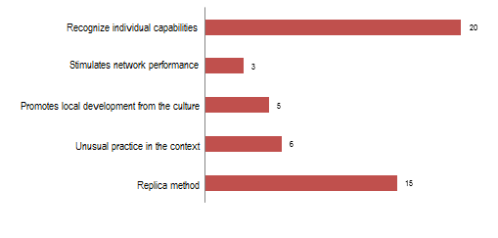
Source: Authors, 2015.
Among the 50 surveyed Points of Culture, 70% self declare perform innovative activities in their practices. It is an important given, since the intention to develop an innovate practice is stage to perform the same. It is noteworthy that 31% of the Points of Culture replicate existing methods, are bringing to their realities and contexts the social technologies, Thus, the concept of social innovation, in its complexity and actuality of construction, is open to new readings.
In the analysis of processes, organizational dynamics can be seen from the perspective of stages in the development of social innovations in order to subsidize public development policies (Murray, Caulier-Grice and Mulgan, 2010). These stages consist of: (1) Inspiration; (2) Proposals and ideas; (3) Prototypes and pilots; (4) Support; (5) Design and dissemination; (6) systemic change, as illustrated below.
In order to check the stage of social innovation of Points of Culture, the aspects considered were related to project activities (from conception to evaluation): space to develop new products, implementation of financial planning, expansion plans of the Organization/project and the occurrence of the theme of innovation in organizational planning.
41% of the surveyed Points of Culture present second phase characteristics of proposals and ideas. This stage is associated with emphasis on performing the planned activities. They are usually organizations with less operating time than three years.33% of the Points of Culture are in support stage where there is more attention to the economic and financial planning and the team is back efforts for obtaining and allocating resources.18% of the Points of Culture are in diffusion phase, which already planning future activities and intend to expand the project.In the first stage are found 4% of the Points of Culture. At this stage of Inspiration, the team focused on the perception of a social problem, paying attention to the symptoms and seeking to emergency response through traditional actions.And at the other extreme, there are 4% of the Points of Culture that already are found in the sixth stage of innovation: systemic change, which implies a permanent and sustainable change.
The following chart illustrates the percentage of Points of Culture in innovation stages, using the method Murray, Caulier-Grice and Mulgan (2010).
Points of Culture in innovation stages
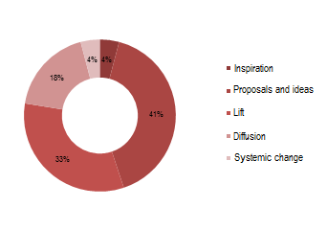
Source: Authors, 2015.
It’s important to note that, according to the authors, these steps are not always sequential, with possible feedback and interaction between them. In the organizational context, certain projects may have more innovative features than others and also be in differentiated stages.
The above scheme allows us to understand the sources of income of the initiatives, although most of them becomes from selling its own products (5), followed by the public sponsorship (5), private sponsorship (4) and both public and private source of income (3).
Analyzing the way, the coordinators are doing business and the stage of innovation, the results shows large majority in support phase (41 %), followed by 29% of proposals and ideas and 24% in the diffusion phase. 6% are in the initial phase of innovation, which is the inspiration. There are initiatives in systemic change phase.
Graphic 3 - Initiatives and stage of innovation

Source: Author's elaboration

5.Partnerships
From the mapping of partnerships of Points of Culture to individuals, social organizations and / or businesses the features of methodological support were observed by professionals (human resources), infrastructure assignment (physical resources), products trading practice and services, sponsorship or funding and even political discourse identified as partnerships.
50 Points of Culture have signed partnerships with 161 organizations, among them, 39% are initiatives of civil society organizations such as non-governmental organizations, associations or foundations. 27% of partnerships are made public, especially the schools of the City and State Network, and funding bodies. 26% of partnerships with private companies refer to sponsorship and funding, providing products and services at low cost and donations.
Among the initiatives of civil society, there is great emphasis on partnerships within the local place where is observed the dissemination of works, supply of materials, services and people. In the territory, they are also effective partnerships with residents association, collective and churches.
Partnerships with the public sector, in addition to the recognition of the Ministry of Culture and the Municipal Culture as a financier and other sectoral bodies, such as IPHAN or educational institutions such as UFRJ.
Among the partnerships with companies, and the investment of financial resources, the counterparts in goods and services are some of the ways of relationship between the Culture Point and the private sector. As previously seen in "Financial resources", the public and private financing are the main ways to facilitate the work of most of the Points of Culture.
It is difficult to reproduce this article all identified partnerships, for example
Illustrated with the North Zone points of the city of Rio de Janeiro. In this phase of the study did not assess the amount of employment or income but only relations. These aspects will be addressed in the next survey.

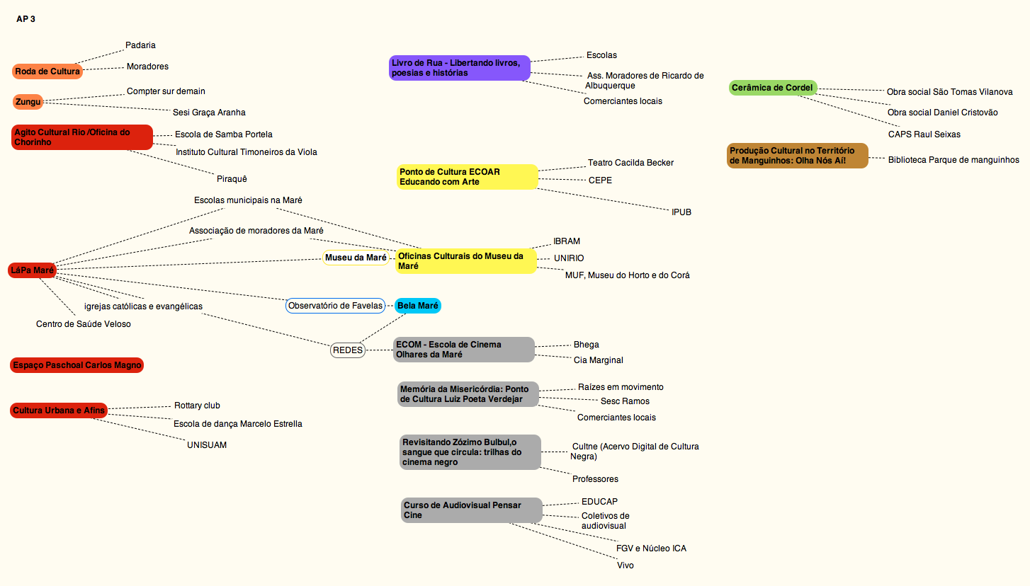

6. Conclusion
Survey responses led to reflections on (1) the understanding of creative economy as a social innovation in low income community contexts; (2) the use of the creative sector activities to promote citizenship and generation of employment and income; (3) small entrepreneurship NGOs linked to larger structured organization; and (4) the connection of productive-creative activities with the local cultural tradition.
The literature on creative economy in low-income community is scarce in Brazil, from the production point of view. The research project conducted by LARES (CNPq/MINC /SEC) in 50 Points of Culture in Rio de Janeiro, identified new theoretical and conceptual aspects of the creative economy in vulnerable social contexts. The number of informal settlements hides the volume of initiatives, the quality and the dynamism of them. And what draws attention to the potential consumer market, offers clues that there resident population, although it has informal sources of funds, are spending and entering the market, using technology, access to networks, communication, etc. (Maimon et al, 2014)
Another connection is made through the welfare and training practices in these activities, indicating some sort of educational value and promoting citizenship through arts and cultural expressions.
We observed that aspects of social innovation in the activities promoted by the Points of Culture goes against the demand for the identification and exploitation of technologies developed by organizations working in the cultural sector. It is highlighting cultural diversity and foster the exchange of methodologies in a coordinated network. These aspects are of great importance in the leverage of project results and fostering the sustainability of organizations.

7. Bibliographic referencies
BIGNETTI, L.P. “As inovações sociais: uma incursão por ideias, tendências e focos de pesquisa”. CiênciasSociaisUnisinos, v.47, n.1, p. 3-14, 2011.
BITTENCOURT, L.N. “Social Organizations and Government Actions in Public Culture in Action”, 2014.
BOUCHARD, M. “Social innovation, an analytical grid for understanding the social economy: the example of the Quebec housing sector”. Serv Bus, v.6, n.1, p. 47-59, 2012.
IPEA.“Panorama of the Creative Economy in Brazil”.Org. Oliveira, John Maria. Texto for discussion / Applied Economic Research Institute. Brasilia: Rio de Janeiro, 2013.
KLEIN, J.-L., FONTAN, J.-M, HARRISON, D.; LEVESQUE, B. « L’innovation social e au Québec: un système d’innovation fondé sur la concertation". Cahier du CRISES, collection Études théoriques, No ET 0907, 2009.
LEVESQUE B. « L’innovation dans le développement économique et le développement social ». In:Klein J-L, Harrisson D (eds) L’innovation sociale. Emergence et effets sur la transformation des sociétés.Presses de l’Universite´ du Québec, 2007.
LIMA, S.M.S. “Creative poles - A study of small Brazilian creative territories”. Brasilia, 2012.
MINISTRY OF CULTURE OF BRAZIL. “Plan of the Secretariat of the Creative Economy: Policies, guidelines and actions, 2011 to 2014”. Brasilia, 2012. Available at: http://www.cultura.gov.br/site/wp-content/uploads/2012/04 / Ledger portuguesweb.pdf. Access to December 11, 2013.
SCHACHTE, M.E.E.; MATTI, C.; ALCANTARA, E. “Fostering Quality of Life through Social Innovation: A Living Lab Methodology Study Case”. Review of Policy Research, v. 29, n.6, p. 672-692, 2012.
MURRAY, R.; CAULIER-GRICE, J.; MULGAN, G. “The Open Book of Social
Innovation”. London, NESTA/The Young Foundation. 2010. Available in
www.nesta.org.uk/publications/assets/features/the_open_book_of_social_innovation. Accessed February 2015.
REIS, Ana Carla Fonseca. “Creative economy as a development strategy: a view of developing countries”. São Paulo, Itaú Cultural, 2008.
UNCTAD. “Creative Economy Report - Creative Economy: A Feasible Development Option” - Geneva: United Nations, 2010.

Economist, PhD in Economy of Development (Ecole des Hautes Études en Sciences Sociales). Coordinator of Laboratory of Social Responsibility and Sustainability – IE/UFRJ.Professor at Institute of Economics – IE/UFRJ
Social Scientist, Master Student on Production Engineering at COPPE/UFRJ.
Cultural Producer, consultant at Laboratory of Social Responsibility and Sustainability – IE/UFRJ.
In 2015, LARES-IE/UFRJ reseachers have conducted a project of mapping the creative economy at Mangueira’s favela.
The Brazilian Institute of Geography and Statistics -IBGE (Brazilian Bureau of Census)
As previously said, the variation of culture activities is recurrent in the Points of Culture. Some examples in activities realized: “Workshop theater, percussion and workmanship” (Music in the square). In this case, the category defined to Cultural area of the Project was “Music”, once “percussion” is the most popular activity and pointed as most innovative work tool, related with the historical of the organization.

