X Godard (01/07/13)

Exposé de cadrage : *Développement des transports collectifs en Méditerranée : quelles réponses adaptées à des besoins croissants ?*

Le discours international dominant pour le développement des transports collectifs

Contre les modes individuels… VP (mais aussi moto)

Pour quelles raisons, avec quels objectifs ?

* Social (accessibilité à la ville pour tous)
* Impact urbain ‘coupure et espace occupé par infrastructures)
* Coût économique (infra, usage)
* Energie consommée
* Environnement (pollution émise, GES)

Attention au dogmatisme, système plurimodal à gérer, complémentarités à trouver

* Importance des pôles d’échanges

Quels TC ?

* Entreprises
  + Autobus
  + BRT
  + Tramway
  + Métro
  + Train urbain
* Artisanat (débat sur l’informel)
  + Taxi collectif
  + minibus

Pour quelle clientèle et quels besoins à satisfaire ?

Les difficultés principales :

* financières
* institutionnelles
* cohérence des formes urbaines

Les réponses en Méditerranée du sud

* Tunis précurseur, mais a raté la dynamique
* Le Caire un métro très apprécié mais trop lent à construire
* Algérie, Maroc, des investissements lourds pour rattraper le temps perdu

Des initiatives en réseau…

1.2: Global motor vehicle projections to 2050, in millions



Source: IEA, 2009.

**Table 2:  Share of public transport forms in travel in North Africa**

**(in percent)**

|  |  |  |  |  |  |  |  |  |  |  |  |  |  |  |  |  |  |  |  |  |  |  |  |  |  |  |  |  |  |  |  |  |  |  |  |  |  |  |  |  |  |  |  |  |  |  |  |  |  |  |  |  |  |  |  |
| --- | --- | --- | --- | --- | --- | --- | --- | --- | --- | --- | --- | --- | --- | --- | --- | --- | --- | --- | --- | --- | --- | --- | --- | --- | --- | --- | --- | --- | --- | --- | --- | --- | --- | --- | --- | --- | --- | --- | --- | --- | --- | --- | --- | --- | --- | --- | --- | --- | --- | --- | --- | --- | --- | --- | --- |
| |  |  |  |  |  | | --- | --- | --- | --- | --- | | City | Algiers  2004 | Cairo  2008 | Casablanca  2004 | Tunis  2002 | | Shared taxis | 3 | - | 21,5 | - | | minibuses | 53 | 36 | - | - | | **Total artisanat** | **56** | **36** | **21,5** | **-** | | Institutional transport | 3,5 | 32 |  | 40 | | Specialised transport | 8 | 7 |  | - | | **Total public/collective transport** | **67,5** | **75** | **50** | **40** | | private car | 29 | 17 | 30 | 50 | | metered taxis | 3 | 7 | 11 | 10 | | two wheelers | 0,5 | 1 | 9 | - | | **Total individual transport** | **32,5** | **25** | **50** | **60** | |

Source: Codatu (2008) and unpublished sources

Figure 5.7: Influences of urban densities on transport-related energy consumption, 32 cities, 1989

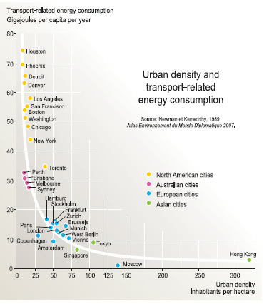

Source: Newman and Kenworthy, 1989; Lefevre, 2009.

Figure 5.8: The spatial distribution of population densities in seven cities in the 1990s

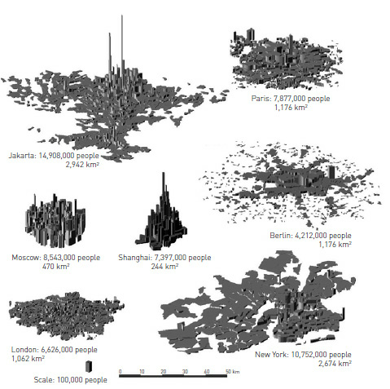

Source: Bertaud, 2001.

Figure 5.18: Spatial evolution of Copenhagen, Denmark: From finger plan (left), to five-corridor railway investment (middle), to rail-oriented urbanization

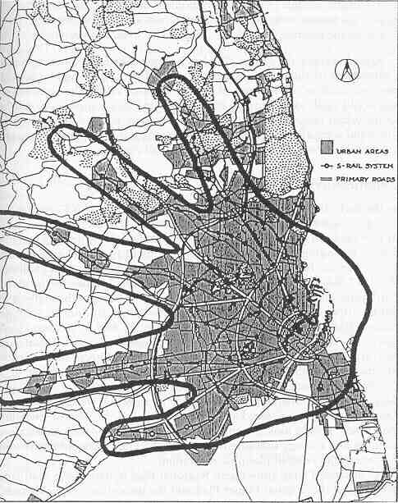 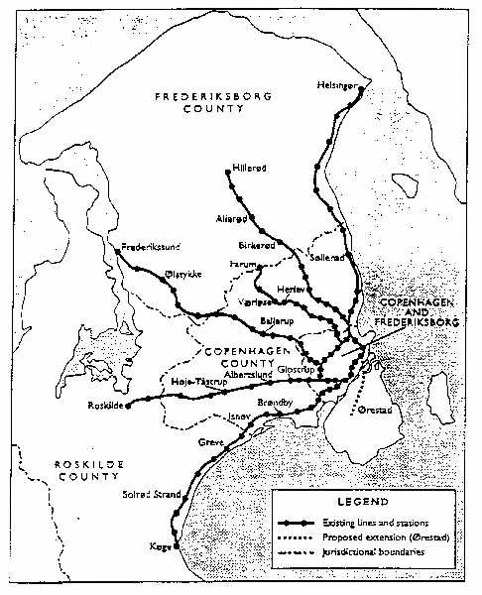 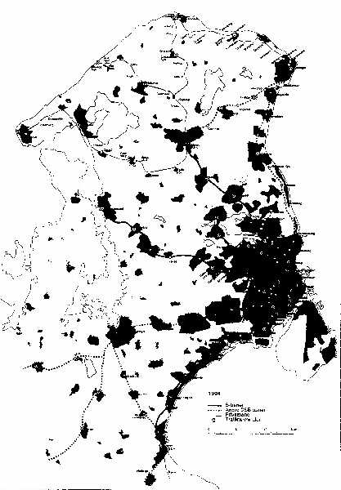

Source: Cervero, 1998.

Figure 5.19: Comparison of urban forms and transport-sector carbon emissions in Atlanta (US) and Barcelona (Spain)

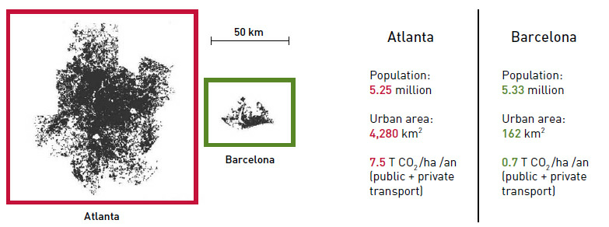

Sources: Newman and Kenworthy, 1999; Bertaud and Richardson, 2004; Lefevre, 2009

Figure 5.27: Curitiba’s trinary road system, Brazil

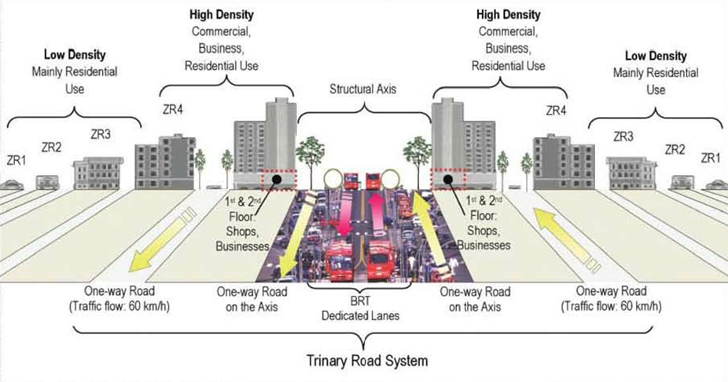

Source: Suzuki et al, 2010.

**Table 5: Fuel prices in various African countries (unit: Us cents)**

|  |  |  |  |  |
| --- | --- | --- | --- | --- |
| Country | 2000 | | 2008 | |
| diesel | Super gazoline | diesel | Super gazoline |
| **Sub Saharan** |  |  |  |  |
| Angola | 15 | 30 | 39 | 53 |
| Benin | 39 | 48 | 103 | 103 |
| Burkina | 46 | 68 | 133 | 138 |
| Cameroon | 47 | 58 | 104 | 114 |
| Cote d’Ivoire | 51 | 76 | 120 | 133 |
| Ethiopia | 27 | 48 | 89 | 92 |
| Gabon | 39 | 64 | 90 | 114 |
| Guinée | 69 | 85 | 102 | 102 |
| Kenya | 60 | 71 | 114 | 120 |
| Mali | 43 | 110 | 104 | 130 |
| Niger | 48 | 68 | 111 | 114 |
| Nigeria | 27 | 27 | 113 | 59 |
| South Africa | 50 | 50 | 84 | 85 |
| Senegal | 52 | 73 | 126 | 135 |
| Tanzanie | 73 | 75 | 99 | 104 |
| Tchad | 60 | 68 | 132 | 130 |
| Togo | 40 | 48 | 88 | 89 |
| **North Africa** |  |  |  |  |
| Algeria | 15 | 27 | 20 | 34 |
| Egypt | 10 | 26 | 20 | 49 |
| Libya | 16 | 25 | 12 | 14 |
| Morocco | 53 | 82 | 83 | 129 |
| Tunisia | 29 | 49 | 84 | 96 |

Source GTZ 2010

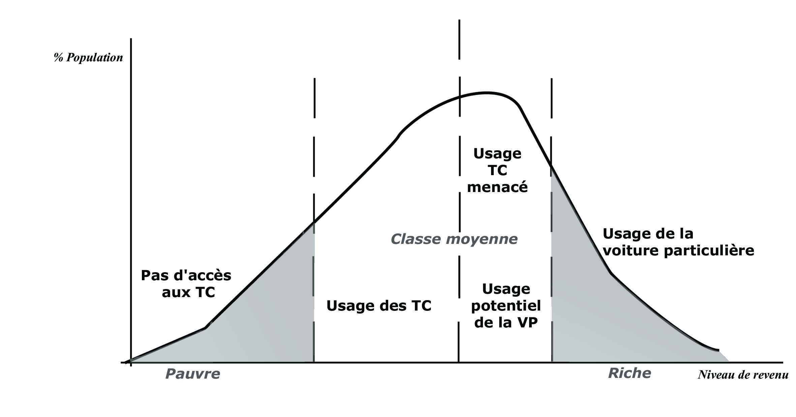

Le dilemne de l’offre de transport public: qui vise-t-on?

